Pizza Sales SQL Queries

1. **KPI’s**
2. **Total Revenue:**

select SUM(total_price) AS Total_Revenue FROM dbo.pizza_sales

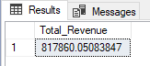

1. **Average Order Value:**

SELECT SUM(total_price) / COUNT(DISTINCT order_id) AS Avg_Order_Value FROM pizza_sales

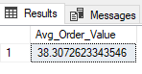

1. **Total Pizzas Sold:**

SELECT SUM(quantity) AS Total_Pizza_Sold FROM pizza_sales

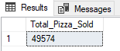

**4. Total Orders:**

SELECT COUNT(DISTINCT order_id) AS Total_Orders FROM pizza_sales

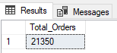

**5. Average Pizzas Per Order:**

SELECT CAST(CAST(SUM(quantity) AS DECIMAL(10,2)) / CAST(COUNT(DISTINCT order_id) AS DECIMAL (10,2)) AS DECIMAL (10,2)) AS Avg_Pizzas_Per_Order FROM pizza_sales

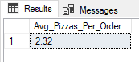

1. **Charts**
2. **Daily Trend for Total Orders:**

SELECT DATENAME(DW, order_date) AS order_day, COUNT(DISTINCT order_id) AS Total_orders FROM pizza_sales

GROUP BY DATENAME(DW, order_date)

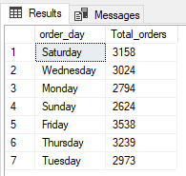

1. **Monthly Trend of Total Orders:**

SELECT DATENAME(MONTH, order_date) AS Month_Name, COUNT(DISTINCT order_id) AS Total_Orders FROM pizza_sales

GROUP BY DATENAME(MONTH, order_date) ORDER BY Total_Orders DESC

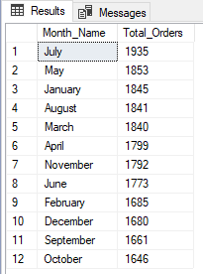

1. **Percentage of Sales by Pizza Category:**

SELECT pizza_category, SUM(total_price) AS Total_Sales, SUM(total_price) * 100 / (SELECT SUM(total_price) FROM pizza_sales WHERE MONTH(order_date) = 1) AS PCT FROM pizza_sales

WHERE MONTH(order_date) = 1

GROUP BY pizza_category

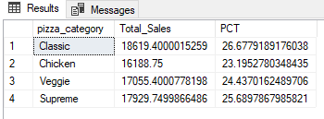

1. **Percentage of Sales by Pizza Size:**

SELECT pizza_size, CAST(SUM(total_price) AS DECIMAL(10,2)) AS Total_Sales, CAST(SUM(total_price) * 100 / (SELECT SUM(total_price) FROM pizza_sales WHERE DATEPART(QUARTER, order_date)=1) AS DECIMAL(10,2)) AS PCT FROM pizza_sales

WHERE DATEPART(QUARTER, order_date)=1

GROUP BY pizza_size

ORDER BY PCT DESC

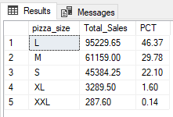

SELECT pizza_size, CAST(SUM(total_price) AS DECIMAL(10,2)) AS Total_Sales, CAST(SUM(total_price) * 100 / (SELECT SUM(total_price) FROM pizza_sales) AS DECIMAL(10,2)) AS PCT FROM pizza_sales

GROUP BY pizza_size

ORDER BY PCT DESC

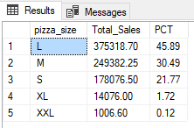

**5. Total Pizzas Sold by Pizza Category**

SELECT pizza_category, SUM(quantity) AS Total_Pizzas FROM pizza_sales

WHERE MONTH(order_date) = 1

GROUP BY pizza_category

ORDER BY Total_Pizzas DESC

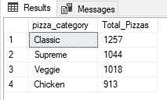

SELECT pizza_category, SUM(quantity) AS Total_Pizzas FROM pizza_sales

GROUP BY pizza_category

ORDER BY Total_Pizzas DESC

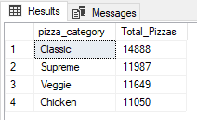

**6. Top 5 Best Sellers by Revenue, Total Quantity and Total Orders**

SELECT TOP 5 pizza_name, SUM(total_price) AS Total_Revenue FROM pizza_sales

GROUP BY pizza_name

ORDER BY Total_Revenue DESC

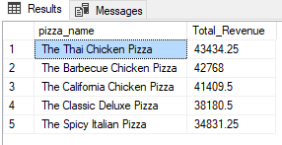

**With Respect to Quantity:**

SELECT TOP 5 pizza_name, SUM(quantity) AS Total_Quantity FROM pizza_sales

GROUP BY pizza_name

ORDER BY Total_Quantity DESC

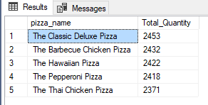

**With Respect to Total Orders:**

SELECT TOP 5 pizza_name, COUNT(DISTINCT order_id) AS Total_Orders FROM pizza_sales

GROUP BY pizza_name

ORDER BY Total_Orders DESC

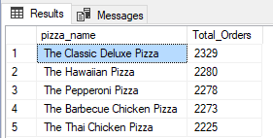

**7. Bottom 5 Best Sellers by Revenue, Total Quantity and Total Orders**

SELECT TOP 5 pizza_name, SUM(total_price) AS Total_Revenue FROM pizza_sales

GROUP BY pizza_name

ORDER BY Total_Revenue ASC

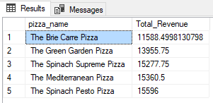

**With Respect to Quantity:**

SELECT TOP 5 pizza_name, SUM(quantity) AS Total_Quantity FROM pizza_sales

GROUP BY pizza_name

ORDER BY Total_Quantity ASC

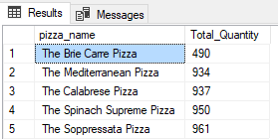

**With Respect to Total Orders:**

SELECT TOP 5 pizza_name, COUNT(DISTINCT order_id) AS Total_Orders FROM pizza_sales

GROUP BY pizza_name

ORDER BY Total_Orders ASC

